Advanced systems for a few observers in the edge city that I select
I plan to have with me, 4 or 5 80mm telescope systems with video recording and accurate timing, that I would like some observers in the graze zone at one of the limits to operate at different locations in the zone. Hopefully, it will be possible to forecast the weather well enough on Aug. 19 or 20, so that I can select the path-edge city that I can then travel to. If so, on Sunday afternoon (Aug. 20), I’d like to meet potential observers in the selected city, so that rather than use just smart phones, they can use these small “eclipse video” systems to record the Baily’s beads and other eclipse phenomena in good detail, from a few locations across the graze zone close to the northern or southern limit of the path of totality.
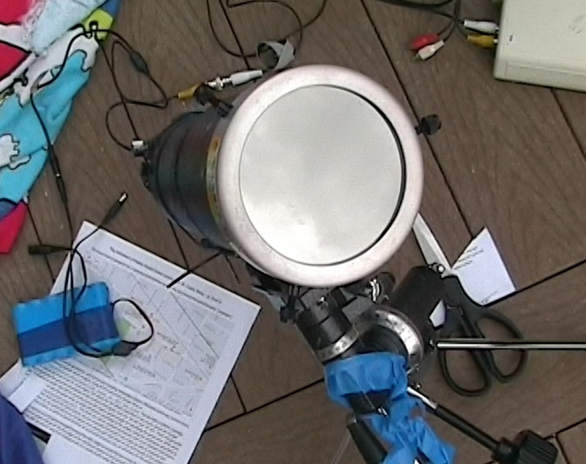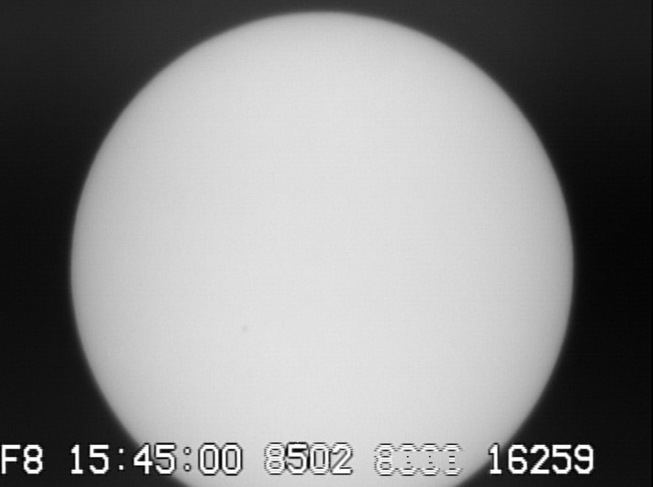
The telescope, a battery pack, and part of the video time inserter are shown at the left. A time-inserted image of the Sun recorded with the system is shown at the right.
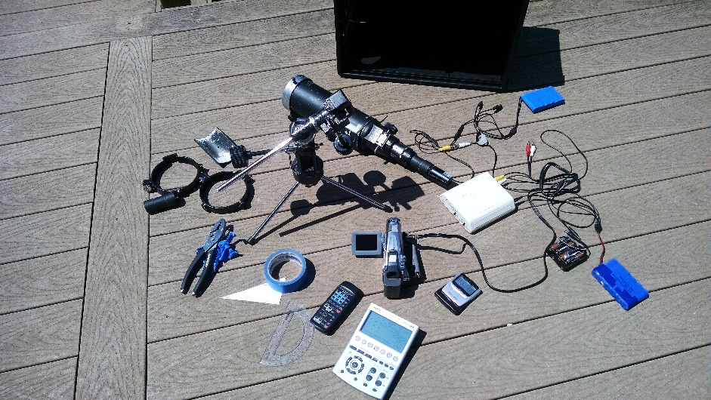
All components of the system are shown above. More information about these systems will be provided before the eclipse.
David Dunham, dunham@starpower.net

